Team assignment 6: Productivity.
Version 0.1.0 created on 20th Mar 2012. By SON dang.

- Purpose.
This document provides information support reader to understand why and how to define productivity of organization (team).
……
- Present productivity on team view.
Productivity is a measurement; help developers measure their effectiveness of work. The simplest way to define productivity is measure OUTPUT/INPUT. In software, this is SIZE/EFFORT. But define exact size or effort in software is a hard work.
In this assignment, we have to define what is the size and effort of our team work.
The size of work can be measured by output of it. We assume our output (product) is score of this assignment. The higher score, the bigger size.
The effort of work can be measured by number of spent hour in assignment of all members.
I will describe how I can give my idea about productivity in following picture. Using GQM approach.
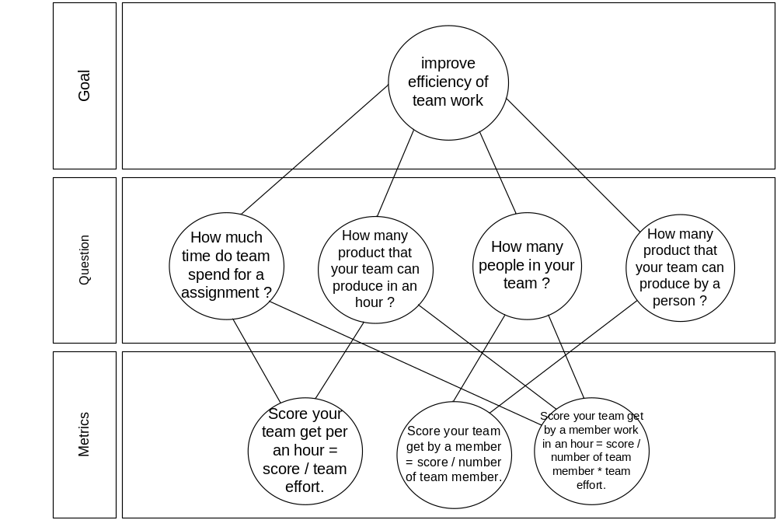
With above set of metrics we can use to measure our team effectiveness, and bring our measurement results compare to the others team.
…….
Addition, we can measure productivity base on size off VikingProject, example: KLOC of program, modules, feature .. and the others

